Content Moderation – Manual

Detect whether an image contains one of 6 exposed body parts:

Male Breast, Female Breast, Male Genitalia, Female Genitalia, Belly, Buttocks.

In order to invoke this service on an image, follow these steps:

1. 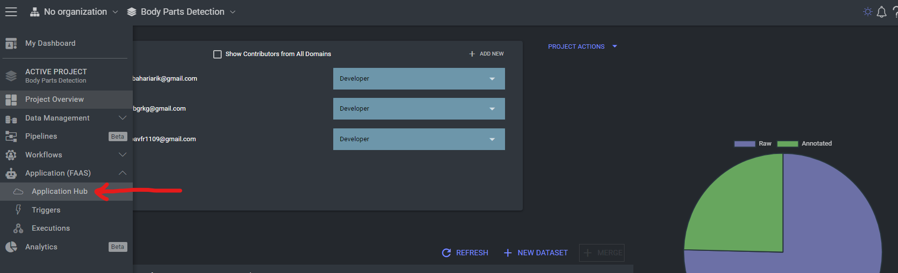Within the project “Body Parts Detection” use the left side menu to navigate to “Application Hub”:
2. Within “Application Hub”, click “Play” on the function named “body-part-detector”:

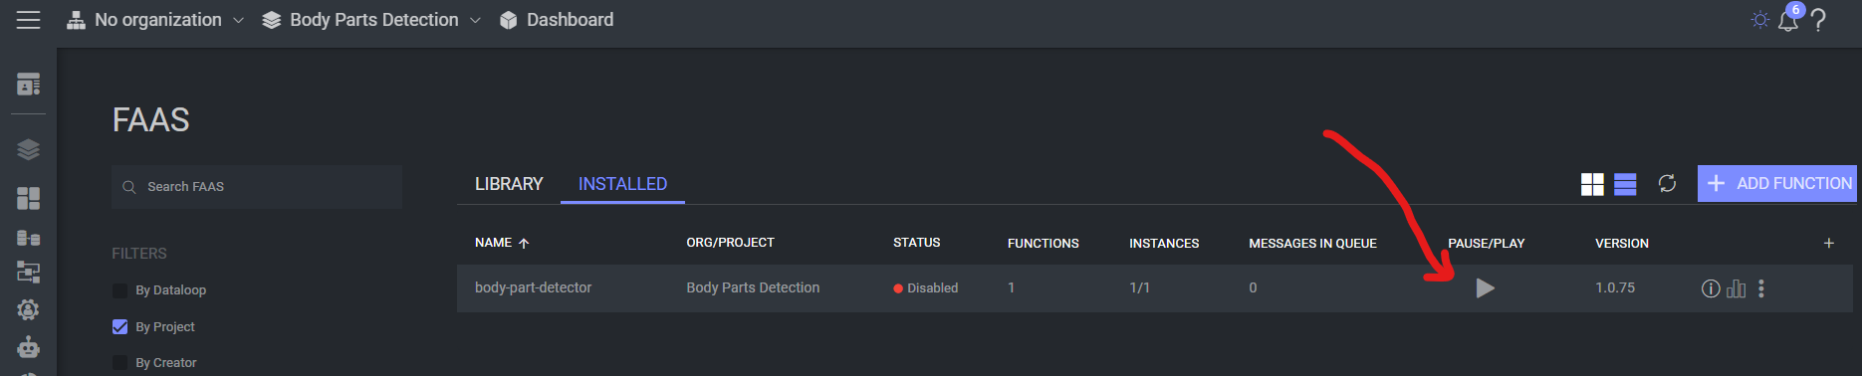

1. 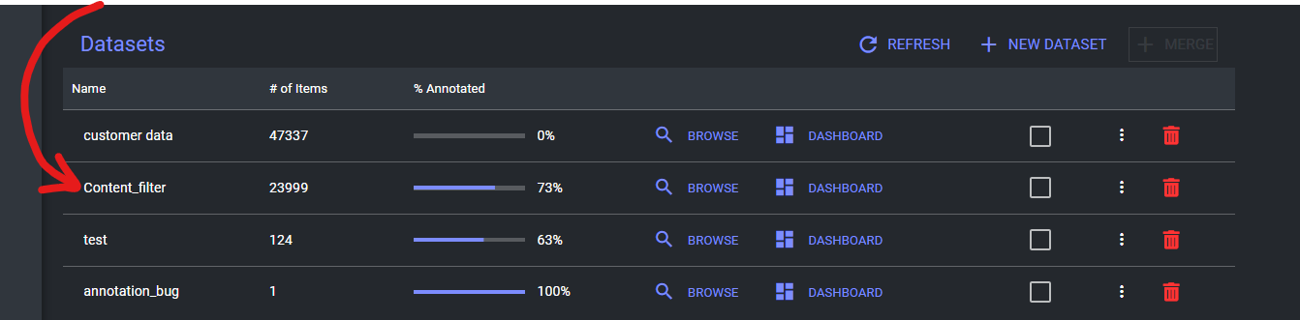Navigate back to the project and browse the dataset “Content_Filter”:
2. Within the dataset, Navigate to the folder “Detect_Input”:

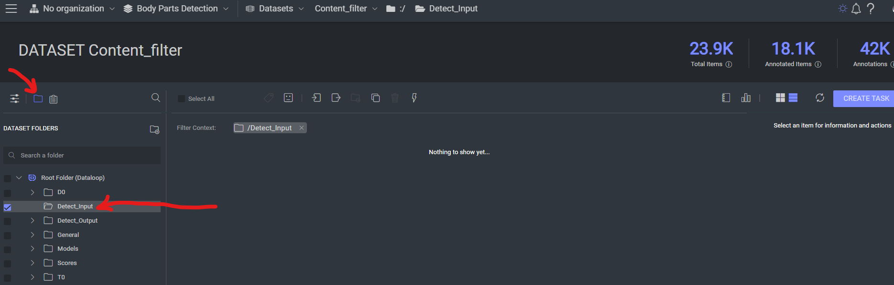

1. Upload an image to the selected folder.
2. View the result annotated photo in the folder “Detect_Output”.